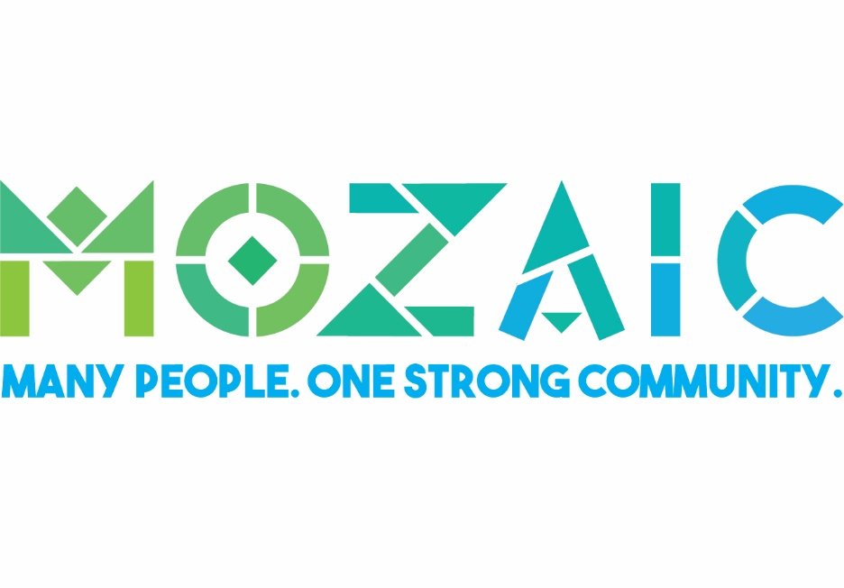

IN-KIND GIFTS & DONATIONS

Name of Business (if applicable): _____________________________________________________

Name: ________________________________________________________________________

Contact Name: ________________________________________ Title: _______________________

Address: _________________________________________________________________________

Telephone #: _____________________ E-mail address: _________________________________

Donation: _________________________________ Value of donation: $ ______________________

Proceeds benefit Mozaic

Please return with in-kind donation form to
Karissa Hefferon, Mozaic
1083 Waterloo-Geneva Road, Waterloo, NY 13165

Contact Karissa at 315-418-8898 or khefferon@mozaic.org with questions or for more info.

www.mozaic.org

